ECG 108:

+ SQR: 55, 2.3s

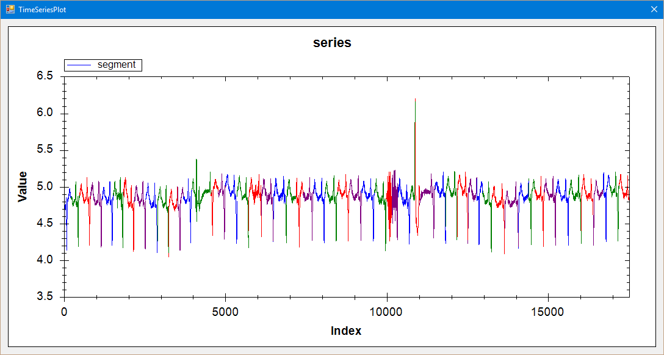

SEP: 178, 0.1s

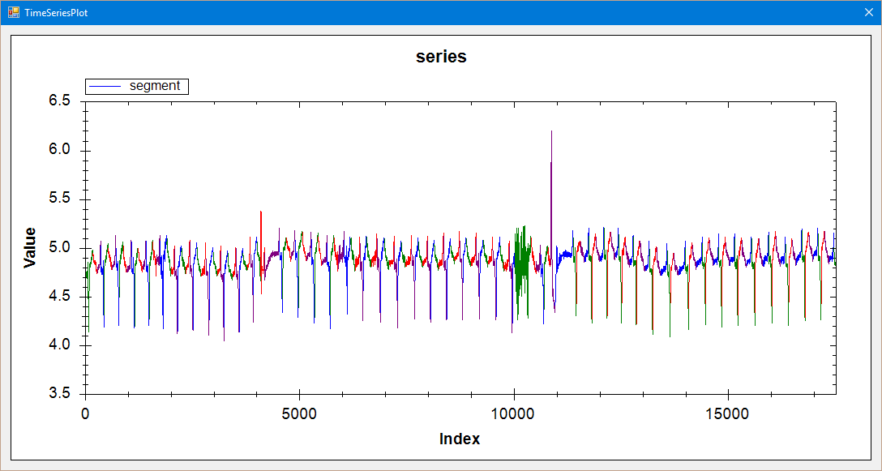

ECG 308:

+ SQR 16, 0.08

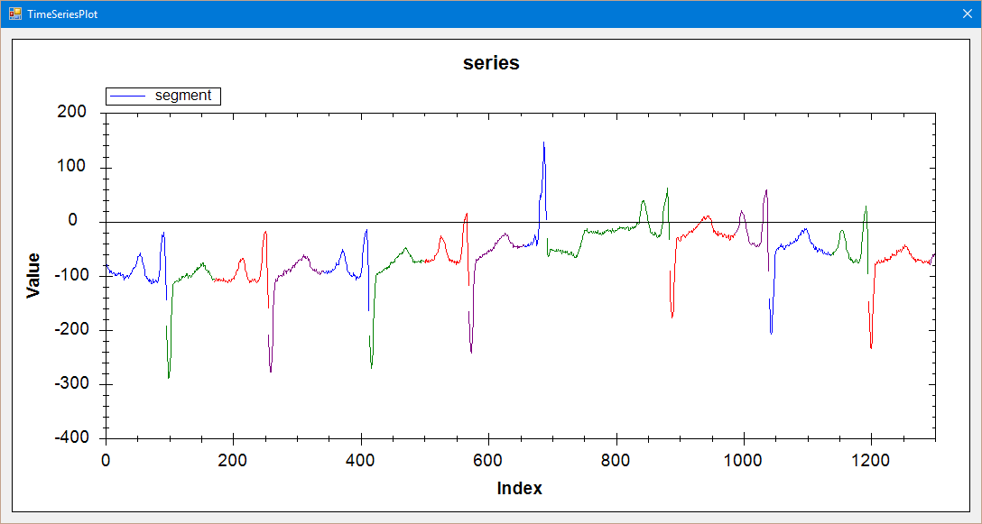

+SEP 47, 0.02s

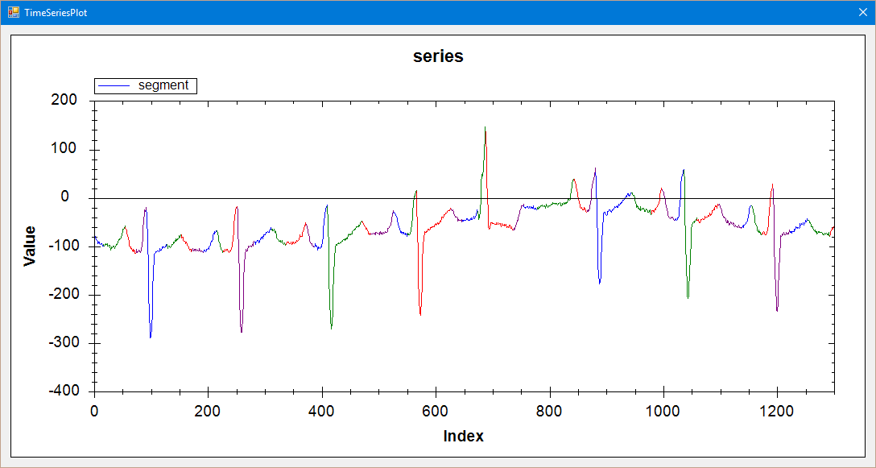

ERP:

+ SQR 89, 0.4s

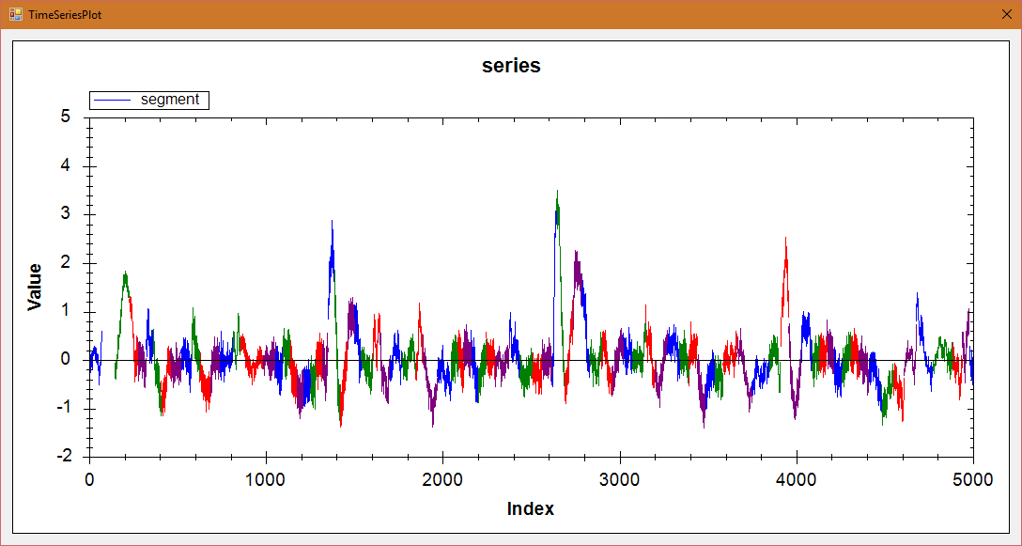

+SEP 127, 0.09s

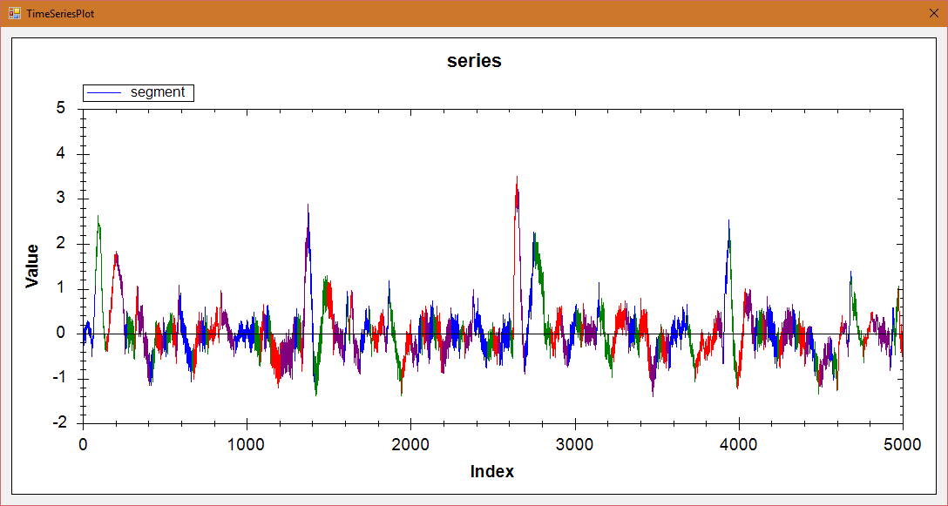

MEMORY:

+ SQR 48, 0.6s

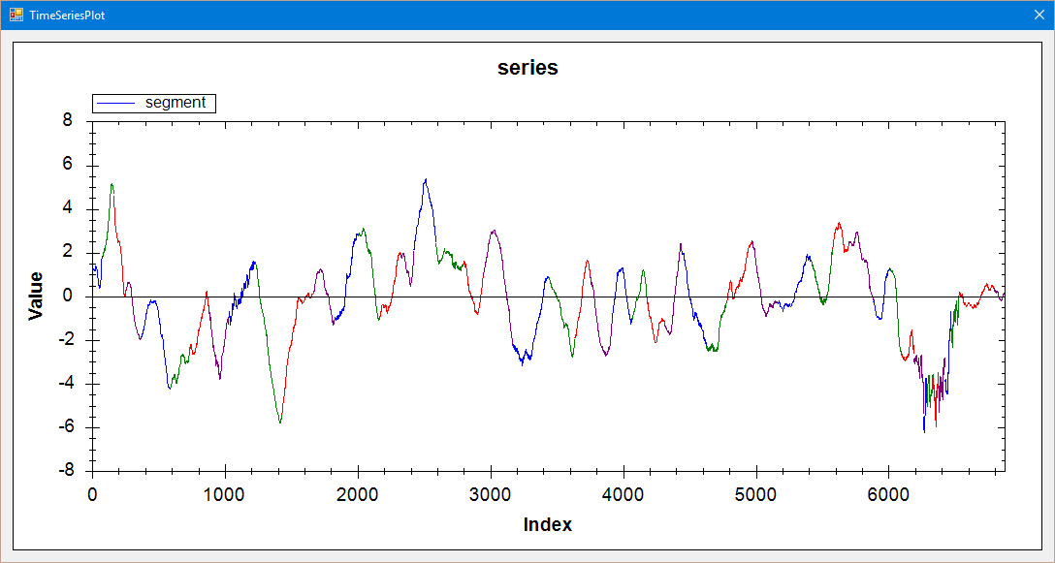

+SEP 66, 0.04

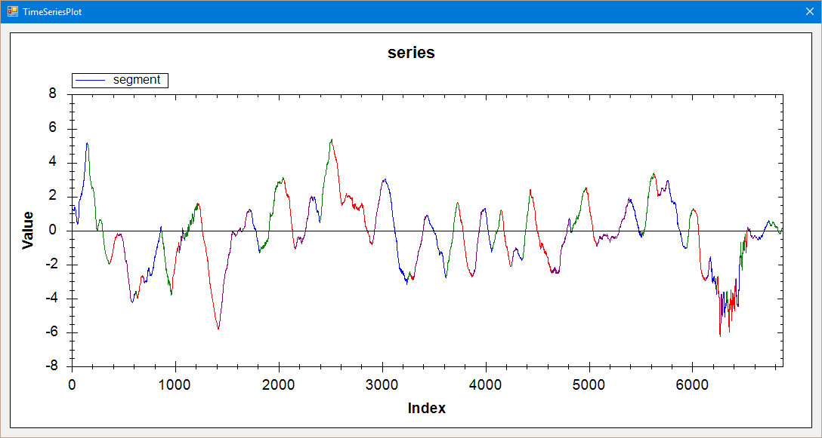

Stock20:

+ SQR 15, 0.7s

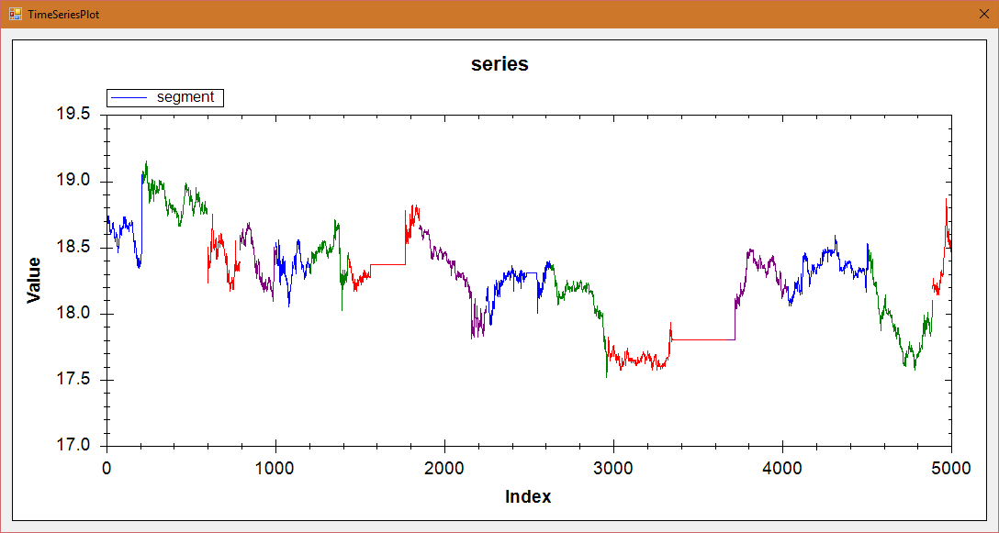

+SEP 8, 0.004s

PowerDustch

+ SQR 18, 1.92s

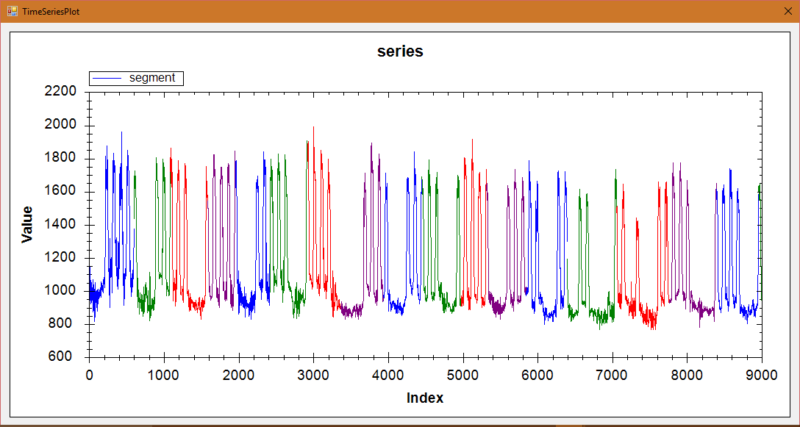

+SEP 15, 0.06

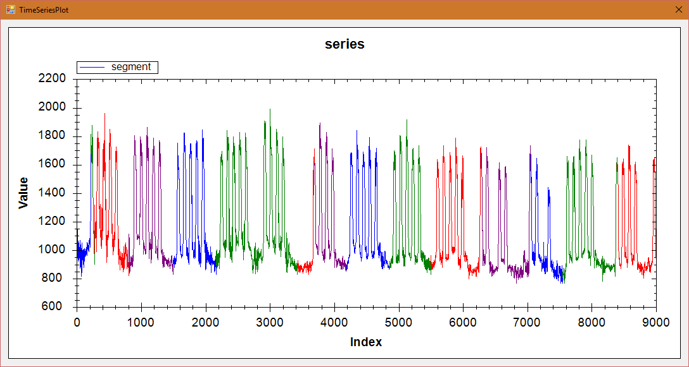

Power Italia

+ SQR 83, 0.57s

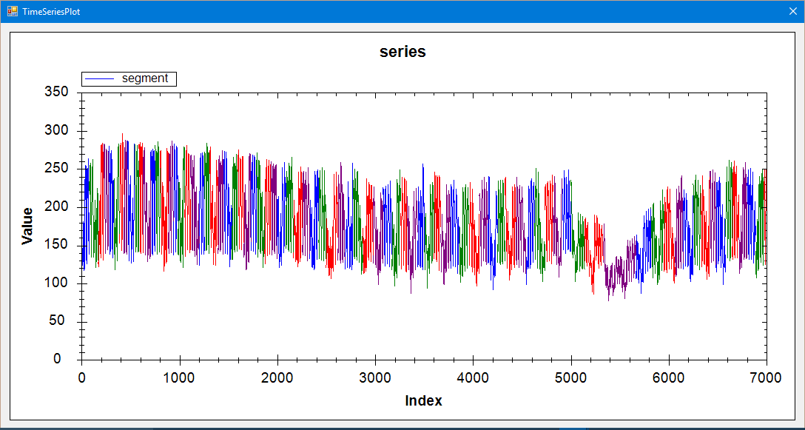

+SEP 85, 0.05s

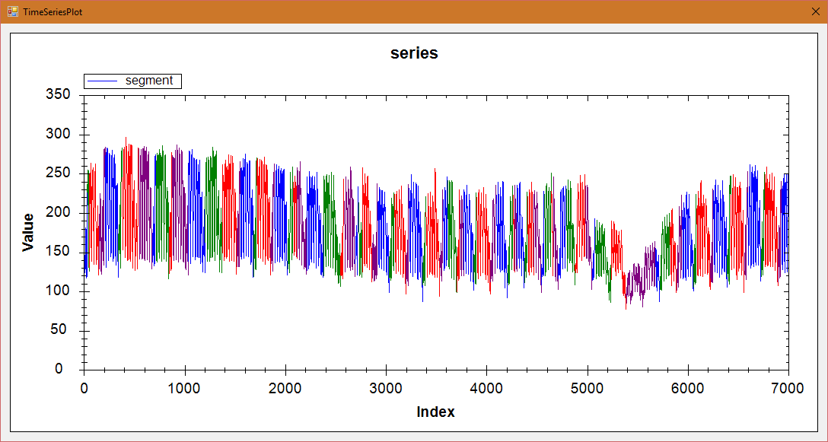

TEK16

+ SQR 21, 0.8s

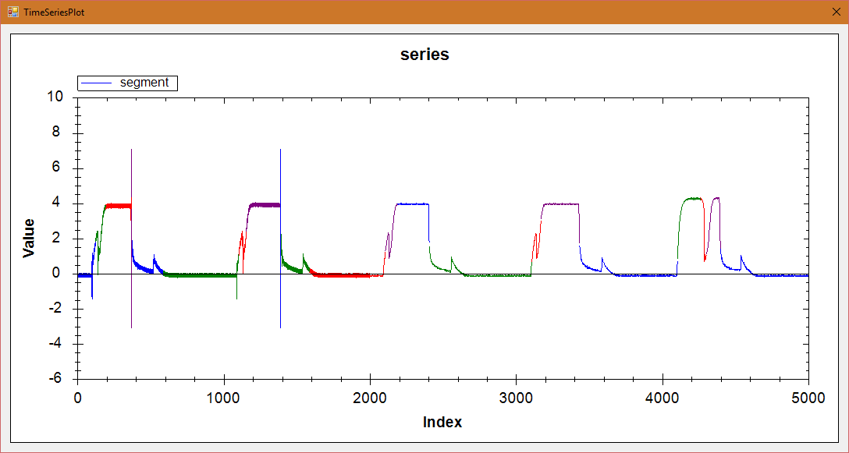

+SEP 14, 0.05s

